**OPERATING**

**SYSTEM**

**LAB – 5**

**System Admin Commands**

**Using Ubuntu App**

**Submitted by: ~**

**Ayushi Kumari**

**RA1911003010865.**

**Q1.** Update the package repositories

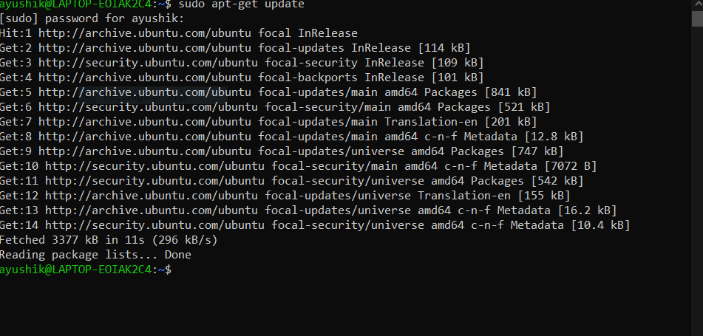

**Q2.** Install the package “simplescreenrecorder” 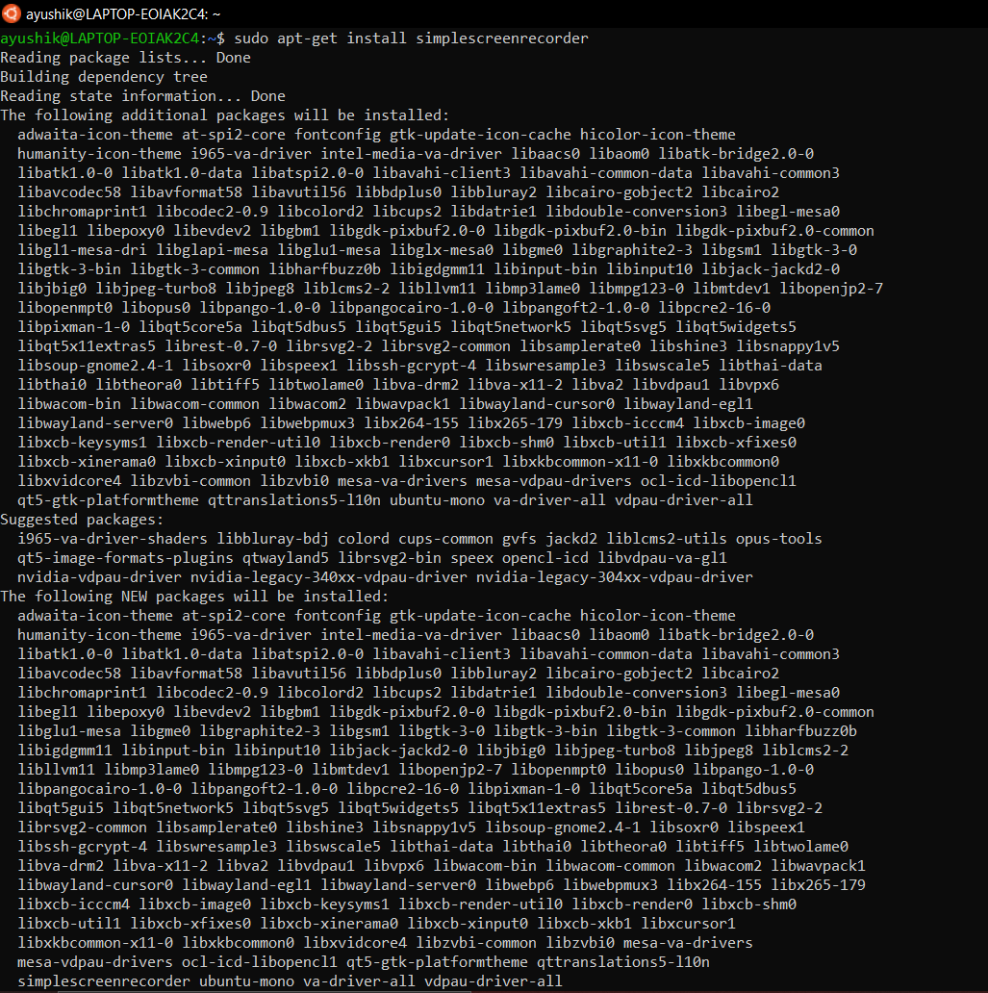

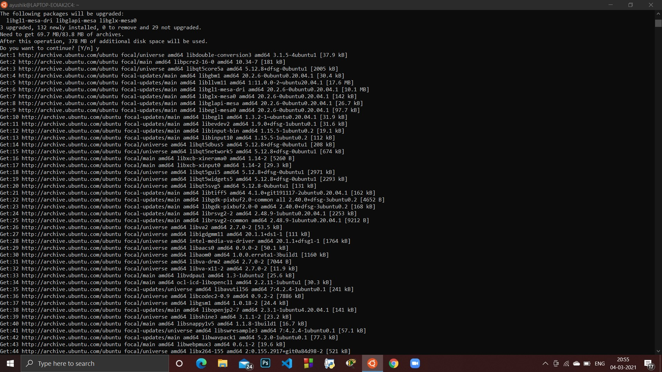

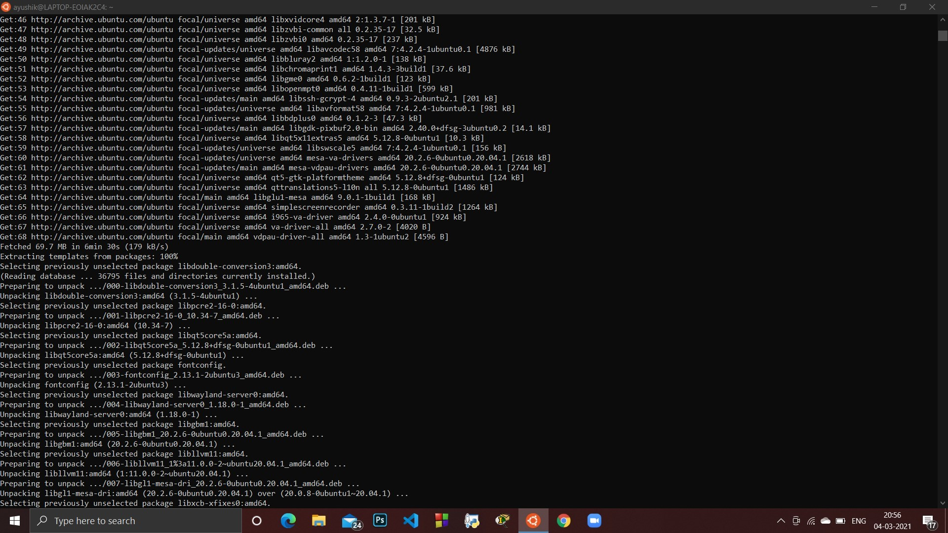

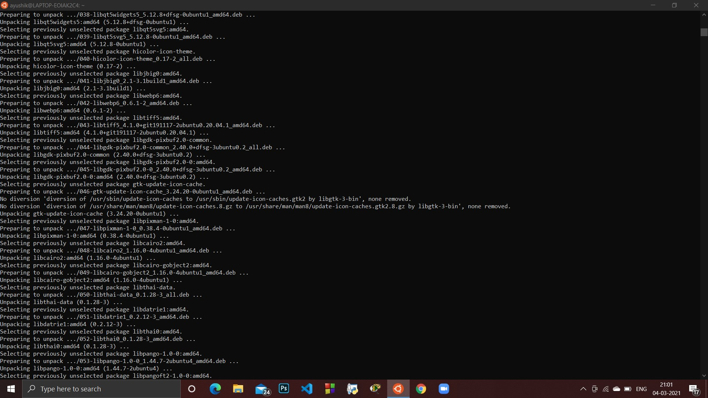

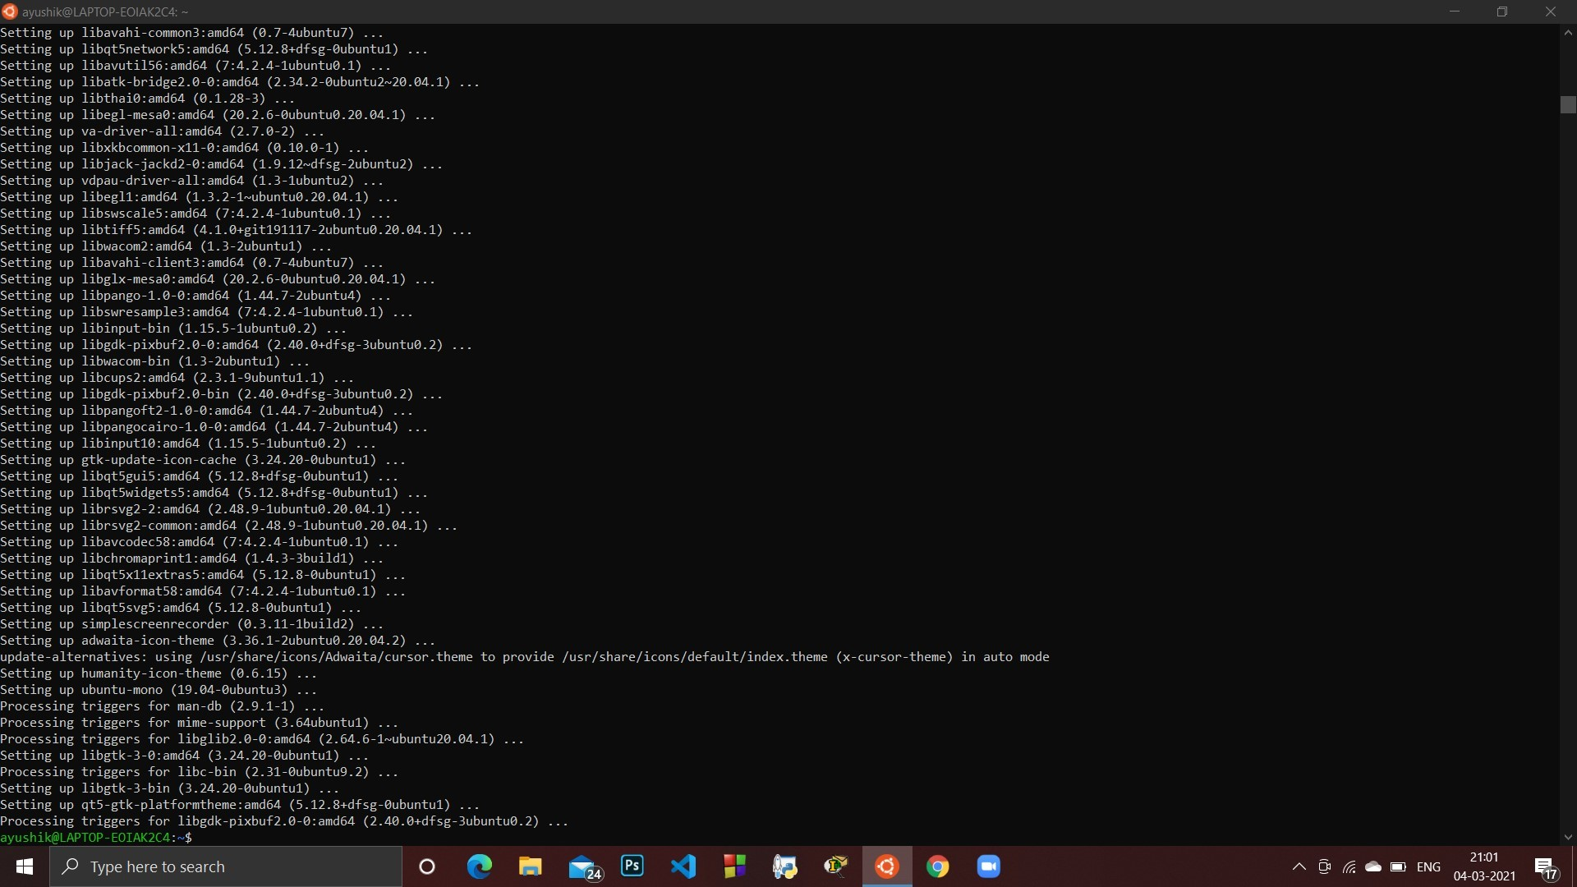

**Q3.** Remove the package “simplescreenrecorder” 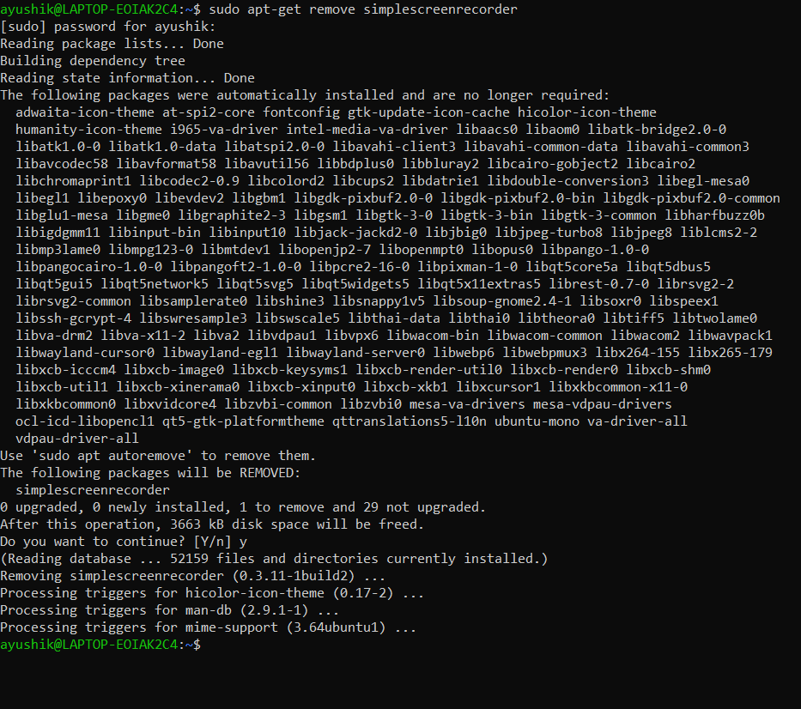

**Q4.** Create a user ‘elias’. Login to the newly created user and exit.

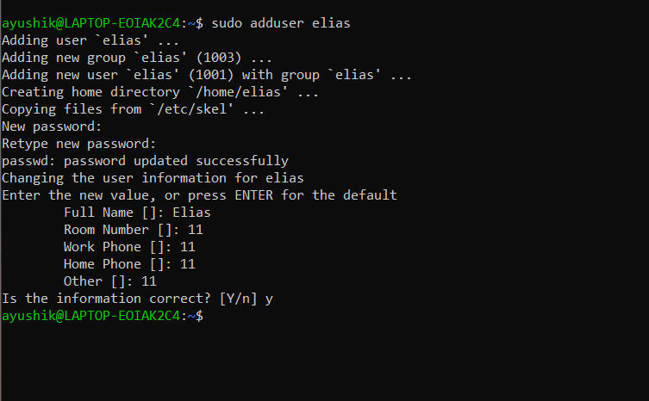

**Q5.** Disable the user ‘elias’, try to login and enable again. 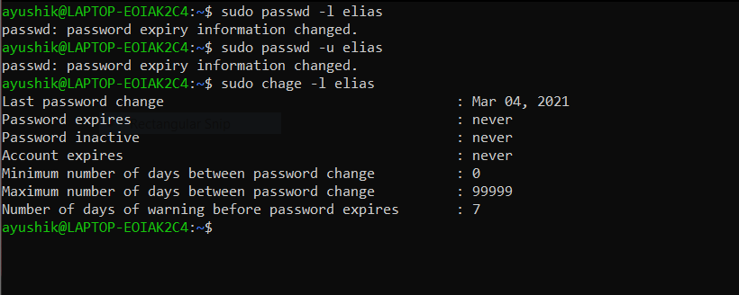

**Q6.** Create a group ‘cse’ and add the user ‘elias’ in that group

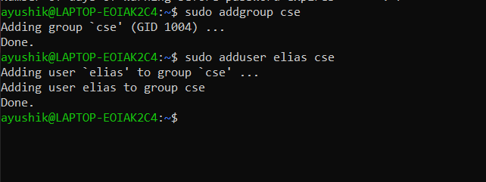

**Q7.** List the account expiry information of the user ‘elias’

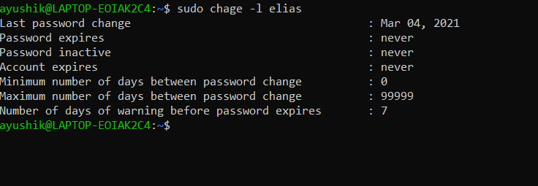

**Q8.** Change the ‘Number of days warning before password expires’ as 5 for the user ‘elias’

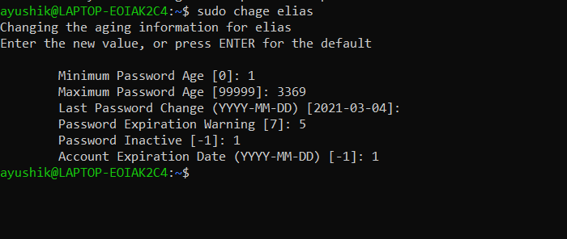

**Q9.** Delete the user ‘elias’ and then delete the group ‘cse’

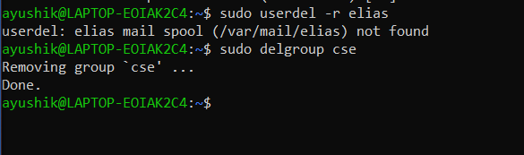

**Q10.** List the partitions available in your system

Command used- sudo fdisk -l

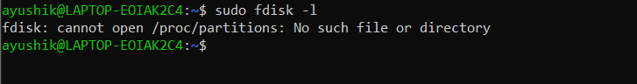

**Q11.** What are the file systems used in your system?

command used- /etc/fstab

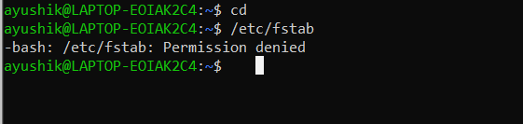

**Q12.** Stop the networking service and then start the service

command used- sudo /etc/init.d/networking stop

sudo /etc/init.d/networking start

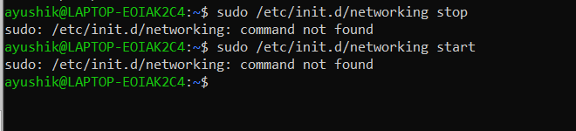

**Q13.** Check the connectivity of the host with IP address 127.0.0.1 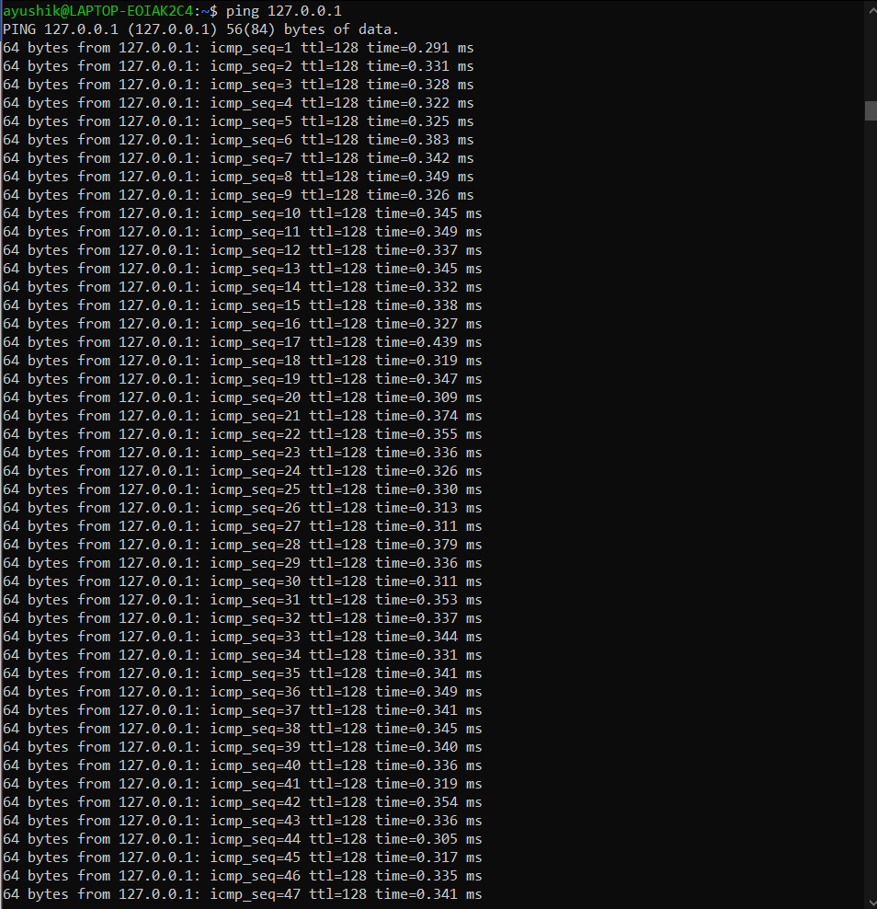

**Q14.** Find the IP address of the localhost 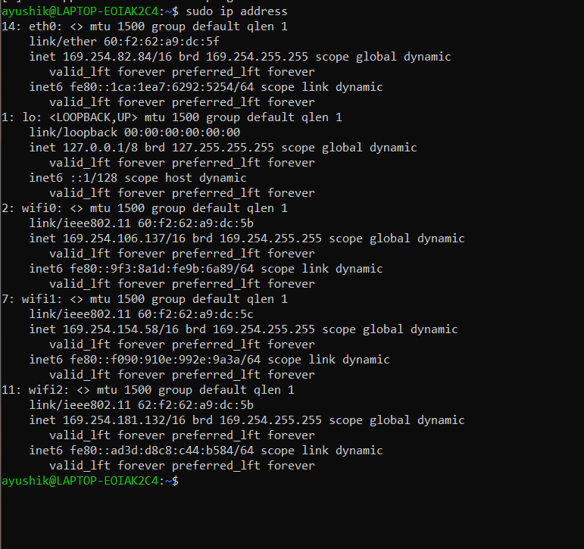

**Q15.** Find the IP address of the DNS Server (name server)

command used- /etc/resolv.conf

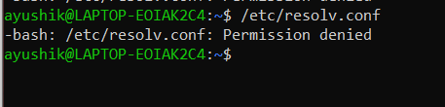

**Q16**. Install mysql server 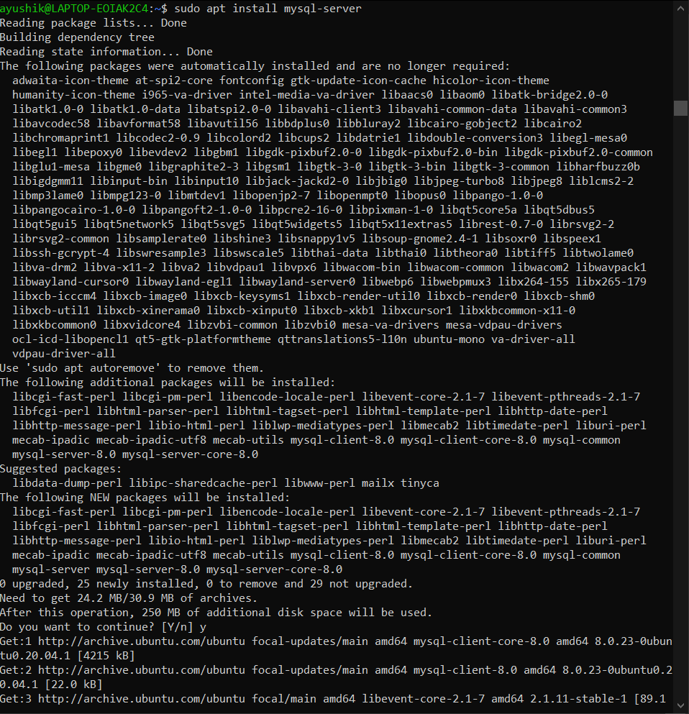

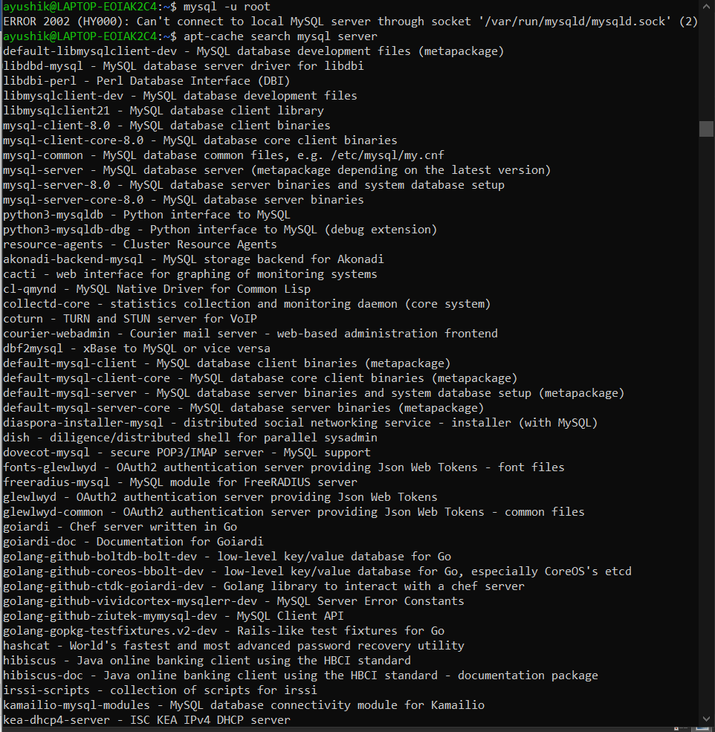

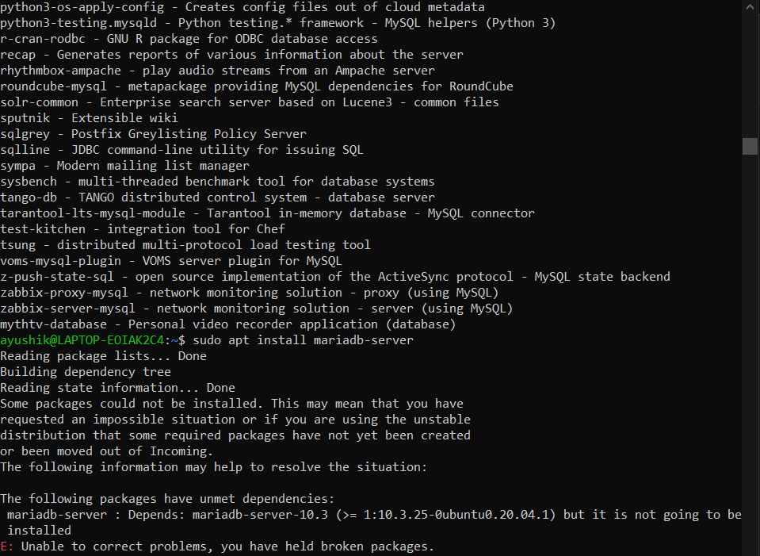

**Q17.** Restart mysql server

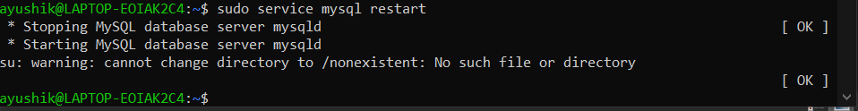

**Q18.** Check the configuration file for mysql server

command used- /etc/mysql/my.cnf

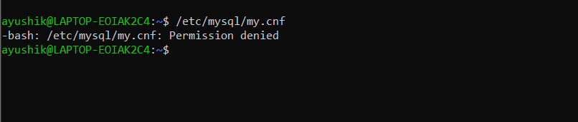

**Q19**. Log on as root into mysql server

command used- mysql -u root

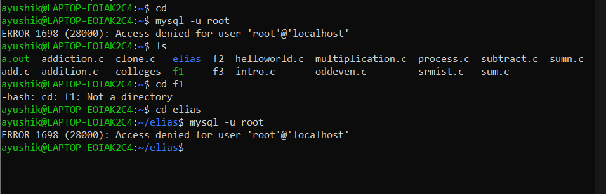

**Q20**. Create a new database for mysql server

command used- mysql -u root

Create database elias

